## INTERNSHIP REPORT

A report submitted to in partial fulfillment of the requirements for the award of the degree of

## BACHELOR OF TECHNOLOGY

**in**

**ARTIFICIAL INTELLIGENCE AND MACHINE LEARNING**

**Submitted by**

**G SNEHITH (22R91A7349)**

**Under the Guidance**

**Of**

**Mr. Sandip Gavit**

## TechnoHacks Solutions Pvt.Ltd.

**Nasik, Maharashtra**

**(Duration: 30TH May, 2024 to 30th June, 2024)**



## Department of Artificial Intelligence and Machine Learning

## TEEGALA KRISHNA REDDY ENGINEERING COLLEGE

**(An Autonomous Institution)**

**Medbowli, Meerpet, Saroornagar, Hyderabad – 500097**

**(Affiliated to JNTUH, Approved by AICTE, Accredited by NBA & NAAC ‘A’) (2024-2025)**

**TEEGALA KRISHNA REDDY ENGINEERING COLLEGE**

**(Sponsored by TKR Educational Society)**

**Approved by AICTE, Affiliated by JNTUH, Accredited by NBA & NAAC-A)**

Medbowli, Meerpet, Saroornagar, Hyderabad – 500 097.

Phone: 040-24092838 Fax: +91-040-24092555

E-mail: [tkrec@rediffmail.com](mailto:tkrec@rediffmail.com) Website: [www.tkrec.ac.in](http://www.tkrec.ac.in)

**Department of Artificial Intelligence And Machine Learning**

# 

# College code: R9

# CERTIFICATE

This is to certify that the Internship report titled “**PYTHON DEVELOPMENT**” is being submitted by **GULLEPELLI SNEHITH** (22R91A7349) is work done by him and submitted during 2024-2025 academic year, in partial fulfillment of the requirements for the award of the degree of Bachelor of Technology in Artificial Intelligence and Machine Learning, at **Teegala Krishna Reddy Engineering College**, Hyderabad.

Internship Coordinator Head of the Department

Sangeeta Jawar

**TABLE OF CONTENTS**

TITLE PAGE NO

1. **Abstract 1**
2. **Introduction 2**
3. **Requirements 3**

3.1 Hardware Requirements

3.2 Software Requirements

3.3 Data Requirements

3.4 Functional Requirements

3.5 User Interface Requirements

1. **Code Explaination 4-6**

4.1 Rock Paper Scissors Game

4.2 Calculator

4.3 Temperature Converter

1. **Significance in Python Development 7**
2. **Conclusion 8**
3. **References 9**

**PYTHON DEVELOPMENT**

**ABSTRACT**

The Python Development internship focused on building foundational skills through the development of three projects: a Rock Paper Scissors game, a Basic Calculator, and a Temperature Converter. The primary aim was to implement core Python programming concepts, including conditional statements, loops, functions, and user input handling. The projects were designed to enhance logical structuring, improve coding practices, and demonstrate the flow of interactive console-based applications. The scope of the internship remained limited to fundamental coding techniques without the use of advanced technologies or graphical interfaces.

**2. INTRODUCTION**

The internship at TechnoHacks Solutions Pvt. Ltd., under the domain of Python Development, provided an excellent opportunity to bridge the gap between theoretical knowledge and practical implementation. Python, known for its simplicity and versatility, was used as the core programming language throughout the internship.

The main objective of the internship was to build fundamental programming skills by developing small-scale, functional applications. The tasks undertaken included creating a Rock Paper Scissors game, a Basic Calculator, and a Temperature Converter — each designed to strengthen concepts such as conditional logic, looping structures, functions, and user input handling.

The scope of the internship was centered around console-based application development, without involving external libraries or graphical interfaces. This approach ensured a deep understanding of Python's core syntax and logic-building strategies, which are essential stepping stones toward advanced programming.

The significance of this internship lies in its contribution to developing structured problem-solving abilities, clean coding practices, and confidence in handling real-world programming tasks independently. By the end of the program, a strong foundation was established, preparing for future challenges in software development, data science, and other Python-related domains.

**3. REQUIREMENTS**

**3.1 Hardware Requirements**

* A personal computer or laptop with basic specifications (2GB RAM or higher).
* Stable internet connection (for downloading Python and related tools).
* Keyboard and display (standard laptop/PC setup for running console-based applications).

**3.2 Software Requirements**

* Python 3.x (latest version preferred).
* Text Editor or IDE: Visual Studio Code / PyCharm / IDLE
* Operating System: Windows / Linux / macOS

**3.3 Data Requirements**

* All inputs are entered manually by the user at runtime.
* Internal data includes user inputs for operations (e.g., numbers for calculator, temperature values, choices for Rock Paper Scissors).
* In-built Python modules like random (for game logic) were used without the need for additional installations.

**3.4 Functional Requirements**

* The application should take input from the user via the console.
* It should process the input using conditional logic and provide accurate results:
  + Rock Paper Scissors: Randomly generate computer choice and compare with user input.
  + Calculator: Perform addition, subtraction, multiplication, and division.
  + Temperature Converter: Convert between Celsius and Fahrenheit based on user selection.

**3.5 User Interface Requirements**

* Console-based user interface (text-only).
* Clear prompts for user input.
* Display appropriate messages, instructions, and results after processing.
* Simple menu-driven format for the Calculator and Temperature Converter.

**4. CODE EXPLAINATION**

**4.1 Rock Paper Scissors Game**

* Developed a console-based Rock Paper Scissors game where a user competes against the computer.
* The computer's choice is randomly generated for each round.

**working:**

* User input was taken to select "rock", "paper", or "scissors".
* Computer choice was generated using the random module:
  + Imported random library to use random.choice() for selecting a move for the computer.
* Conditional statements were used to compare user and computer choices and determine the winner.
* Results (win/lose/draw) were displayed after each game.
* Implemented a loop structure allowing the user to play multiple rounds.
* Ensured the game interface was simple, with clear prompts and outputs.

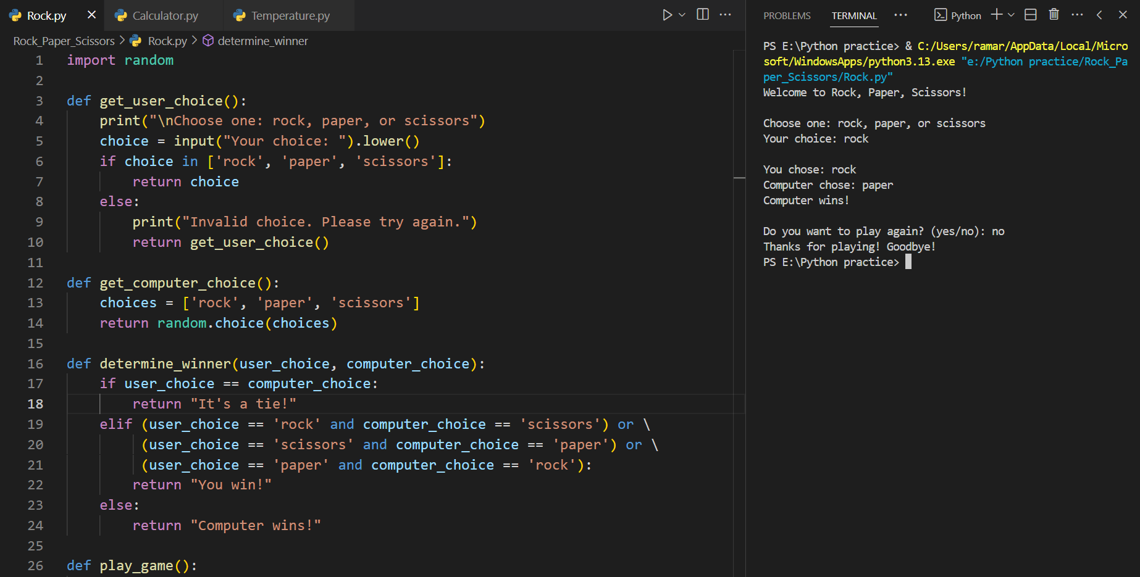

**4.2 Calculator**

* Created a basic calculator program that supports fundamental arithmetic operations: addition, subtraction, multiplication, and division.

**working:**

* Functions were defined separately for each operation to maintain code modularity and clarity.
* User input was collected for selecting the operation and entering the two numbers.
* Mathematical operations were performed using Python's in-built arithmetic operators:
  + +, -, *, and /.
* Input validation was added to handle invalid entries.
* Included error handling for division by zero.
* The program looped back to the menu after each operation unless the user chose to exit.
* The program used only built-in Python libraries (no external imports required for basic math operations).

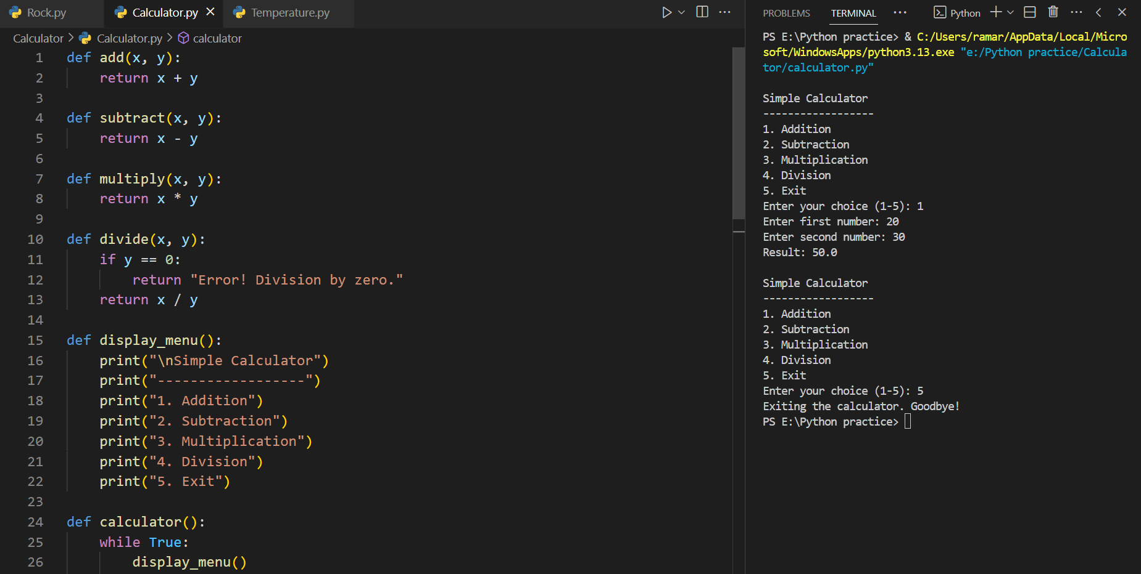

**4.3 Temperature Converter**

* Built a console-based Temperature Converter that converts temperatures between Celsius and Fahrenheit.

**working:**

* Displayed a menu-driven interface for user selection:
  + Celsius to Fahrenheit
  + Fahrenheit to Celsius
* Formulas implemented:
  + Celsius to Fahrenheit: (Celsius × 9/5) + 32
  + Fahrenheit to Celsius: (Fahrenheit - 32) × 5/9
* Collected numeric input from the user for the temperature value.
* Performed the correct conversion based on user choice.
* Used Python's math capabilities (no additional libraries were required).
* Designed a simple, interactive flow to allow repeated conversions until the user chose to exit.

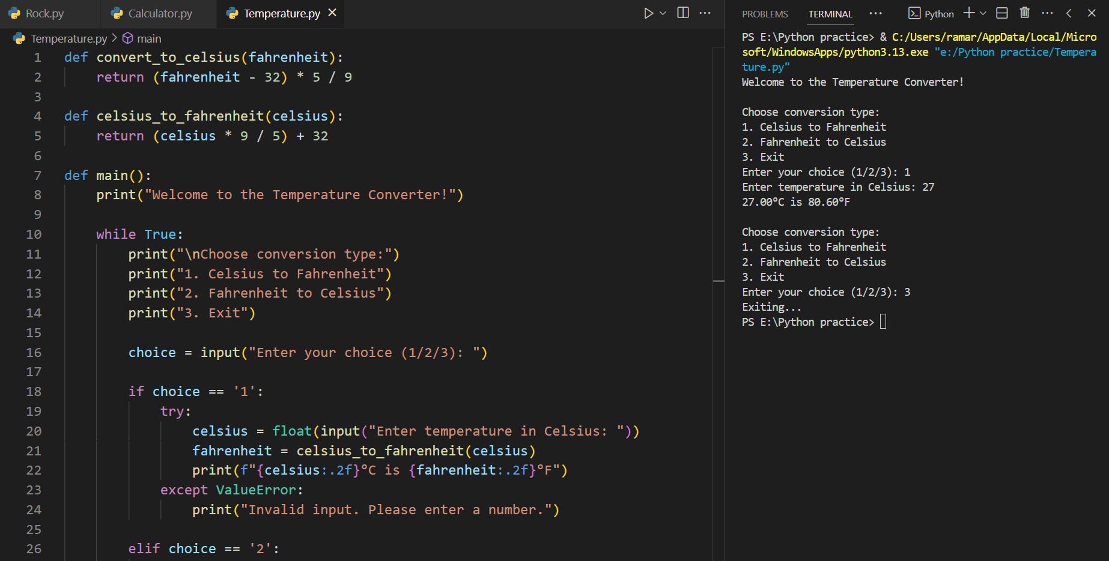

**5. Significance in Python Development**

Python is a versatile and widely used programming language in various industries due to its simplicity, readability, and powerful libraries. The tasks completed such as Rock Paper Scissors, Calculator, and Temperature Converter demonstrate fundamental programming skills that are critical for building more complex applications. These tasks highlight key Python features like conditional statements, loops, and user input handling, which form the foundation of software development.

In the broader scope of Python development, these basic programs serve as introductory steps toward mastering real-world applications in fields like data science, web development, automation, artificial intelligence, and more.

The ability to develop such simple applications showcases problem-solving skills and the practical implementation of core Python concepts. By completing these tasks, developers gain hands-on experience with Python's core functionality, laying the groundwork for more advanced projects and professional growth in the field.

**6. Conclusion**

In conclusion, the journey of completing Python-based tasks such as the Rock Paper Scissors game, Calculator, and Temperature Converter has reinforced fundamental programming concepts and provided a solid foundation for further development. These tasks allowed for the practical application of essential Python features such as functions, control flow, and data types, which are critical to any programming endeavor. As Python continues to grow in popularity and become more integrated into various industries, the skills acquired through these tasks will prove invaluable for tackling real-world challenges. The knowledge gained in this process serves as a critical stepping stone toward more advanced projects and a deeper understanding of Python programming in professional environments.

**7. References**

* Python Documentation: Python Software Foundation. (n.d.). Python 3 documentation. Retrieved from https://docs.python.org/3/
* Automate the Boring Stuff with Python: Sweigart, A. (2019). Automate the Boring Stuff with Python: Practical Programming for Total Beginners (2nd ed.). No Starch Press.
* ISBN-13: 978-1593279929
* Python Programming: An Introduction to Computer Science: Zelle, J. (2010). Python Programming: An Introduction to Computer Science (3rd ed.). Franklin, Beedle & Associates Inc. ISBN-13: 978-1590282755
* Real Python Tutorials: Real Python. (n.d.). Learn Python programming with tutorials, articles, and resources. Retrieved from https://realpython.com/
* W3Schools Python Tutorial: W3Schools. (n.d.). Python Tutorial. Retrieved from https://www.w3schools.com/python/
* Stack Overflow Community: Stack Overflow. (n.d.). Python questions and answers. Retrieved from https://stackoverflow.com/questions/tagged/python
* TechnoHacks - Python Development Certificate Program: TechnoHacks. (2025). Python Development Certificate Program. Retrieved from https://technohacks.co.in/

